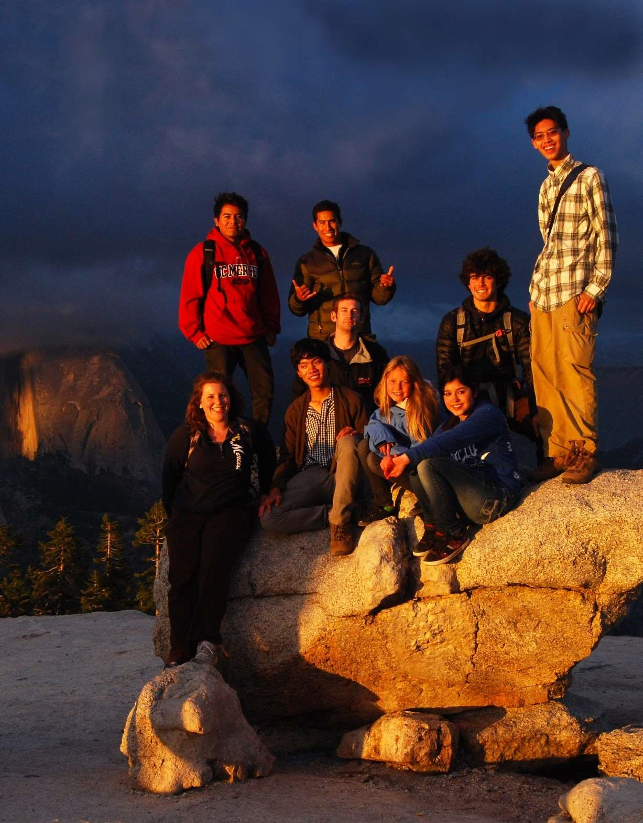
Yosemite Leadership Program:
Summer Internship Descriptions 2024

POSITION: ART and NATURE CENTER INTERN

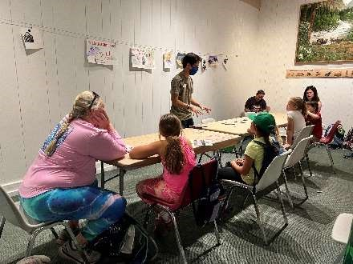
The Happy Isles Art and Nature Center team engages Yosemite National Park visitors of all ages through the creation of art. This operation is run by Yosemite Conservancy, an official nonprofit partner to Yosemite National Park. The intern will serve as a representative of Yosemite Conservancy while supporting the Art Program’s goal of teaching kids and families about Yosemite’s ecology, geology, hydrology, and emphasis of stewardship through art. This is an excellent internship for people who have a strong interest in art, teaching, or non-profits. Most work will be completed outdoors.

What Will I Do?
- Learn and deliver standard art programs centered around park interpretive themes
- Create and present art classes for families with children ages 3 and up
- Teach 2 - 3 short classes per day
- Learn general park information to help guide park visitors.
- Work with the Art Center director and coordinator to design programs that convey park interpretive themes
- Develop and present their own final youth art projects and add to the Art Center’s youth programming resources
- Make presentations in park, public gatherings, and professional meetings

Qualities Supervisors Are Looking For
- Responsible and safe driver
- Strong interpersonal communication skills
- Interest in or experience with public speaking and customer service skills
- Interest in or experience with child development and age-appropriate activities for ages 3 and up
- Interest in or experience with arts, crafts and design
- Interest in learning about Yosemite’s natural and cultural history
- Teamwork/flexibility/resourcefulness in a demanding work environment
- Leadership skills and experience
- Strategic thinking ability
- The ability to self-start/work independently
- The ability to adapt new skills and ideas to the public sector

What Will I Learn?
Through this opportunity, the intern will develop skills and understanding, as well as have personal/professional development experiences in: professional level class facilitation; interpretive education techniques; curriculum development; time management; public speaking skills; customer service skills; positive communication while working within a small team; receiving and implementing feedback.

POSITION: COMMUNICATIONS INTERN

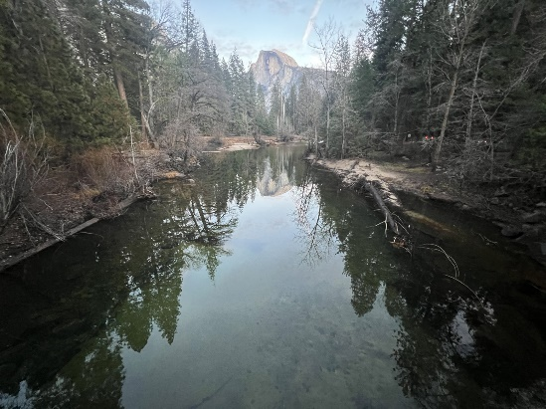
The Communications Intern will work with the Marketing and Communications team at Yosemite Conservancy, the official philanthropic partner of Yosemite National Park. The intern will help tell the stories about the work that the Conservancy is funding and supporting as well as the educational programs the Conservancy provides to the public. They’ll work directly with and shadow Conservancy staff to learn how about modern marketing, communications, and storytelling techniques, including the use of various mediums — such as a blogs, email, social media, and a twice-yearly magazine. This is an excellent internship for creative individuals who have a strong interest in communications, art, and/or nonprofit work.

What Will I Do?
- Learn about the history and relationship of Yosemite Conservancy with the national park
- Learn about the 60+ donor-supported projects the Conservancy is funding in 2024
- Shadow Conservancy Programs in-park staff
- Develop Spanish-language promotions and copy
- Learn how to draft communications for print, web, email, and social media
- Learn basic video editing skills and 508 compliance (accessibility standards for federal communications)
- Develop and present an awareness campaign for one (1) Conservancy project

Qualities Supervisors Are Looking For
- Fluent Spanish speaker
- Responsible and safe driver
- Strong communication skills
- Interest in learning about Yosemite’s natural and cultural history
- Interest in creative tasks
- Feels comfortable troubleshooting technology
- Leadership skills and experience
- Strategic thinking ability
- The ability to self-start/work independently
- Comfort in spending time outside in various weather and terrain

What Will I Learn?
Through this opportunity, the intern will develop skills and understanding, as well as have personal/professional development experiences in: written communication skills, public speaking, research, working on a creative team, social media, networking, 508 compliance/accessibility standards, critical thinking, public outreach.

POSITION: CULTURAL LANDSCAPE INTERN
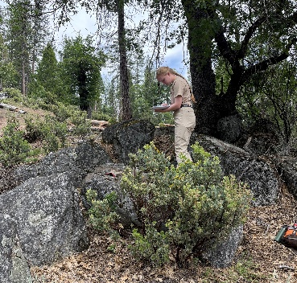
The intern will provide support to the Cultural Resources Branch within the Division of Resource Management and Science. The Cultural Resources Branch completes a diverse range of functions within Yosemite National Park, including research, archeological, anthropological, and historic documentation, assessment and management, project review and support, data management, and strategic planning.

What Will I Do?
- Participate in archeological field surveys to identify archeological sites
- Recording data and help to prepare and manage documentation records
- Assess archeological site condition
- Conduct scientific testing at archeological sites
- Use tools and equipment common to archeological work
- Process artifacts and specimens recovered during fieldwork and prepare them for curation
- Conduct historic and ethnographic research
- Communicate information
- Working independently and as part of a team
- The Cultural Resources Branch is currently working on completing a Cultural Landscape Inventory (CLI) of the Half Dome Trail Corridor at the eastern end of Yosemite Valley. This document will include descriptions and assessments of the long, varied, and ongoing significance of this trail corridor. The intern will learn about cultural landscapes and how we document them, and have the opportunity to provide support for this project.

Qualities Supervisors Are Looking For
- Responsible and safe driver
- Demonstrated leadership skills and experience
- Strategic thinking ability
- The ability to self-start/work independently
- Flexibility/resourcefulness
- The ability to adapt new skills and ideas to the public sector
- Detail-oriented and organized
- Values public outreach and education
- Collaborative team player
- Innovative problem-solver
- Effective oral and written communication skills
- Enjoys working outdoors in variable weather and terrain

What Will I Learn?
Through this opportunity, the intern will develop skills and understanding, as well as have personal/professional development experiences in: leadership skill development, independent project design, time management, critical thinking, cultural resource documentation, cultural landscapes, and compliance with Section 106 of the National Historic Preservation Act.

POSITION: EDUCATION INTERN
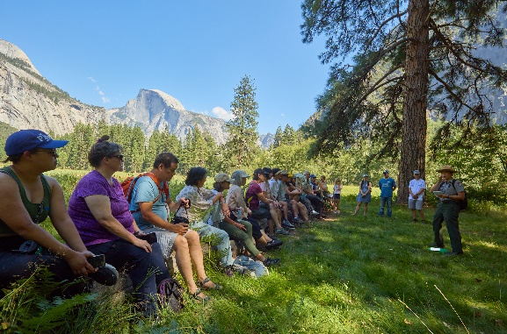
The intern will work within the branch of Education and Community Engagement (EDCE). The intern’s primary project is to research and develop K-8 curriculum that centers around their chosen topic focused on the diverse stories of Yosemite. The intern will also support the EDCE team in connecting, fostering stewardship, and creating opportunities for underrepresented groups in the park.

What Will I Do?
- Learn and research about the diverse stories of Yosemite
- These topics could include but are not limited to: Buffalo Soldiers, Julia Parker, Totuya, Chiura Obata, Tie Sing, George Melendez Wright, Enid Michael
- Create standards based lessons for educators to use in their K-8 classrooms. These self-guided lessons will be accessible on the Yosemite Education page
- Shadow, co-lead, and facilitate educational programs to the general public
- Develop and publish communication and outreach materials on the park’s social media accounts
- Support various community engagement programs in the park
- If applicable, incorporate bilingual components into their programs

Qualities Supervisors Are Looking For
- Interest in learning about Yosemite’s diverse and under told stories
- Interest in or experience with child development and creating age-appropriate activities for students K-8
- Interest in or experience with education and curriculum design
- Interest in or experience with public speaking and customer service skills
- Interest in or experience with creating bilingual content
- Strong interpersonal communication skills
- Teamwork/flexibility/resourcefulness in a demanding work environment
- Leadership skills and experience
- The ability to work independently and take initiative on projects
- Responsible and safe driver

What Will I Learn?
Through this opportunity, the intern will develop skills and understanding, as well as have personal/professional development experiences in: writing standards-based curriculum, public speaking skills; teaching techniques, self-guided research, social media creation, time management, customer service skills, receiving and implementing feedback, communication skills while working in a small team.

POSITION: ENGINEERING INTERN

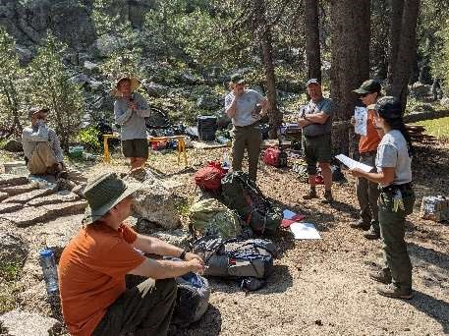
The Design and Engineering Branch performs the planning and design work necessary to ensure park facilities comply with all applicable laws and are constructed safely and efficiently. They work on both large and small scale projects. Using terrestrial LIDAR scanning, the Design and Engineering Branch has been capturing existing park resources and assets to better facilitate management and stewardship. The internship will focus on classifying these scans to identify resources and assets using Artificial Intelligence, algorithmic and manual functions and updating park GIS databases.

What will I do?
- Classify point clouds into regions and point features
- Explore the use of deep learning AI models to increase efficiency of point cloud classification
- Field verification of data
- Develop a Standard Operating Procedure (SOP) on point cloud classification
- Work in collaboration with the Land Surveyor
- Field-work

Qualities supervisors are looking for:
- Demonstrated leadership skills and experience
- Strategic thinking ability
- The ability to self-start/work independently
- Flexibility/resourcefulness
- The ability to adapt new skills and ideas to the public sector
- Highly motivated
- Good writer and communicator
- Enjoys working in a highly collaborative team environment
- Love for the outdoors
- Construction experience a plus, but not required

What will I learn?
Through this opportunity, the intern will develop skills and understanding, as well as have personal/professional development experience in engineering. They will learn to use GNSS RTK and terrestrial LIDAR to create georeferenced point clouds. The intern will be exposed to and learn about reality capture. They will learn the basic use of engineering software such as Civil3D, Trimble Business Center and ArcPro. They will be exposed to park staff and will gain experience in written and oral communication, critical thinking and problem solving, and time management.

POSITION: INDIAN CULTURAL DEMONSTRATOR INTERN

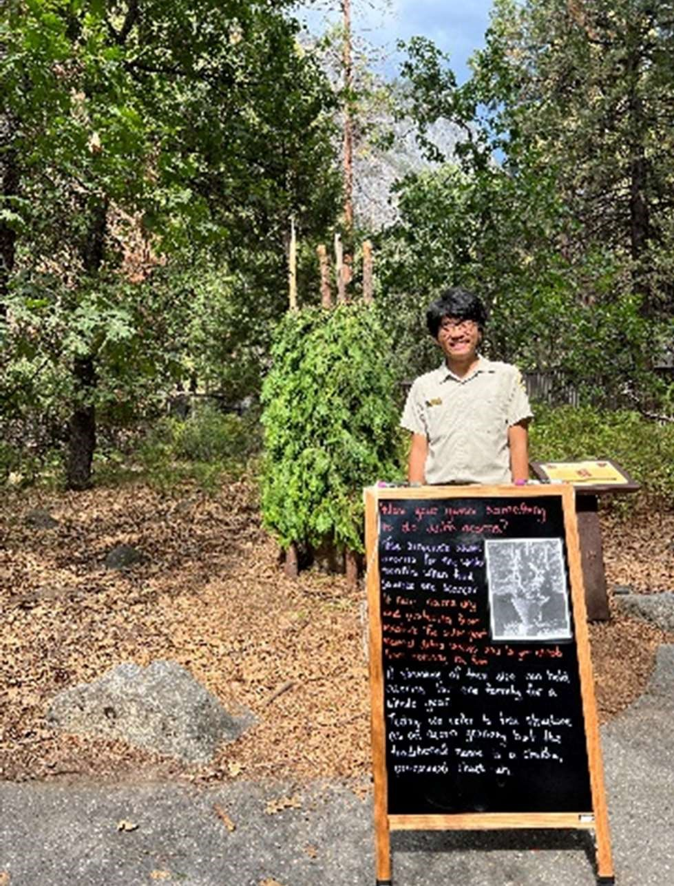
Indian Cultural demonstrators provide contemporary demonstrations of traditional skills and provide a narrative of the Native history of the Yosemite area. They also provide insight to issues important to contemporary Native Americans. The intern will impart knowledge, increase understanding, and inspire respect of traditional beliefs and lifestyles both past and present.

What will I do?
- Research and learn the use and construction of the Umacha (bark house)
- Providing photos and historical context
- Developing a list of materials that will be needed for the project
- Create and present informal pop-up programs designed to engage visitors
- Collaborate with social media team to create content about the Umacha project
- Provide general park information to help guide visitors

Qualities supervisors are looking for
- Basic knowledge of California history and specific interest in native culture
- Excellent communication skills
- Flexibility and resourcefulness
- Ability to physically gather and prepare materials
- Responsible and safe driver

What will I learn?
Interns will learn strategies for interpreting sensitive and controversial cultural topics. They will learn how to interpret an active and living culture. Interns will learn physical construction techniques including tool use and skills in gathering materials. They will gain skills in project management and developing and interpretive production. Interns will learn about the Indian Cultural Program, as well as Yosemite Interpretation.

POSITION: MERCED RIVER ECOLOGICAL RESTORATION INTERN

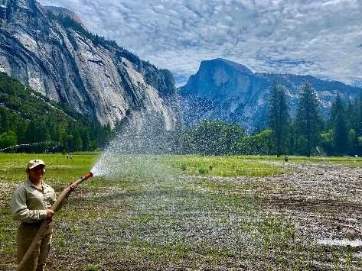
The intern will work within the division of Resources Management and
Science (RMS), in the branch of Vegetation and Ecological Restoration (VER). The intern will be an integral part of a large team working towards protecting, preserving, and restoring meadows, wetlands, and riverbanks.
What will I do?
- Photo point monitoring
- Ecological restoration
- Outreach activities related to the implementation of the Merced
Wild and Scenic River Management Plan
- Social media posts, ArcGIS Story Maps, and other outreach materials
- Translate outreach to reach broader diverse audiences
- Develop and publish communication and outreach materials on the park website and social media accounts
- Assist the program Biological Science Technician with field work on ecological monitoring - Help in restoration activities

Qualities supervisors are looking for:
- Highly motivated
- Very organized
- Takes initiative
- Excellent communicator
- Flexible/resourcefulness
- Attentive to detail
- Skills in computer programs
- Understands introductory ecology
- Willingness to learn
- Spanish-speaking

What will I learn?
Through this opportunity, the intern will develop skills and understanding, as well as have personal/professional development experiences in: Ecological restoration practices and principles, project management and organizational skills, support, and confidence in working independently and as a team research, technical writing, and science communication skills, data collection and management.

POSITION: RECRUITMENT AND RETENTION INTERN (DEIA FOCUS)

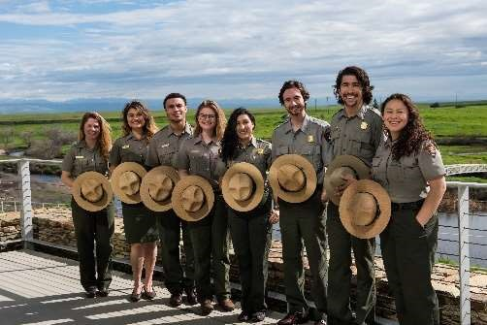
The Recruitment and Retention Intern will support recruitment of new jobs within Yosemite National Park, specifically new recruits in the DEIA category. The intern will support Yosemite’s DEIA efforts and the increase of diversity within the National Park Service’s workforce.

What will I do?
- Meet supervisors from supporting divisions to learn about the division’s needs
- Network with HR Specialists
- Develop and implement a recruitment plan for identified position(s) alongside HR liaison/division supervisors
- Work on data analysis for recruitment plan, if applicable
- Conduct workshops

Qualities supervisors are looking for
- Demonstrated leadership skills and experience
- Strategic thinking ability
- The ability to self-start/work independently
- Flexibility/resourcefulness
- The ability to adapt new skills and ideas to the public sector

What will I learn?
Through this opportunity, the intern will develop skills and understanding, as well as have personal/professional development experiences in: Public speaking, training facilitation, problem-solving, creative communication, community outreach, and data analysis and presentation. A successful intern will have the chance to hone their time management and communication skills through work with multiple stakeholders and partners.

POSITION: TRAILS VOLUNTEER COORDINATOR ASSISTANT INTERN

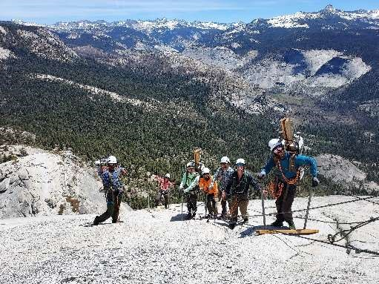
The Yosemite Trail Crew’s Volunteer Facilitation Team host VIP groups throughout the summer season, leading volunteers in basic, but vitally important, trail maintenance and construction tasks. The Trails Volunteer Coordinator Assistant will help establish trails-related and site-specific educational materials and offer presentations of said material to the Park VIP groups.

What will I do?
- Help coordinate and facilitate Volunteers-In-Parks (VIP) project
- Assist with the scheduling and preparation of each VIP project
- Research, prepare, and deliver site-specific interpretive presentations to VIP groups
- Help create VIP folder of interpretive and educational material
- Perform basic trail maintenance and construction
- Video editing and communicating with other staff and stakeholders

Qualities supervisors are looking for:
- Demonstrated leadership skills and experience
- Strategic thinking ability
- The ability to self-start/work independently
- Flexibility/resourcefulness
- The ability to adapt new skills and ideas to the public sector
- Interested in joining over 100 years of tradition
- Enjoys talking to members of the public
- Willing to give short presentations to small groups of volunteers - Hard-worker in a variety of settings

What will I learn?
Through this opportunity, the intern will learn basic tasks of trail maintenance and how to host Park volunteer groups in the performance of said tasks. The intern will also learn to create and offer interpretive presentations to Park volunteer groups.

POSITION: WILDERNESS EDUCATION INTERN
The intern will be a member of a NPS team within the Wilderness branch. This internship works with wilderness staff in Wilderness Centers and on patrol in the field to educate about wilderness permit regulations and expectations. Interns will also deliver interpretive programs about wilderness to Yosemite visitors.

What will I do?
- Receive training in wilderness permits: regulations, issuance, and visitor contact education
- Receive training in wilderness field patrols: backpacking, field work, and visitor contacts
- Receive training in formal programs with interpretation
- Research and create content
- Deliver original interpretive content in front of Wilderness Centers as part of work projects
- Work in multiple wilderness centers, conduct field patrols throughout the park, learn a lot and have fun!

Qualities supervisors are looking for:
- Interested in working with a team in both an office and field setting including overnight camping—backpacking experience not required.
- Interest or experience in public speaking/presentations
- Interest in or experience with Leave No Trace
- Interest in learning and growing, including asking questions and being curious
- Able to work with groups of all ages and backgrounds

What will I learn?
Through this opportunity, the intern will develop skills and understanding, as well as have personal/professional development experiences in: Professional-level Wilderness education and management, backpacking skills and decision making, public speaking skills; teaching techniques, self-guided research, time management, customer service skills, receiving and implementing feedback, communication skills while working in a small team.

